A chordophone uses vibrating…  Sound Smart  Name:  Highlight the correct answer for each question. | - air  - strings  - solid objects  - thin stretched skin
An ideophone uses vibrating… | - air  - strings  - solid objects  - thin stretched skin
A aerophone uses vibrating… | - air  - strings  - solid objects  - thin stretched skin
A membranophone uses vibrating… | - air  - strings  - solid objects  - thin stretched skin
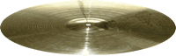  This instrument is a … | - aerophone  - chordophone  - ideophone  - membranophone
This instrument is a …  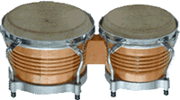 | - aerophone  - chordophone  - ideophone  - membranophone
This instrument is a …  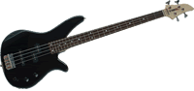 | - aerophone  - chordophone  - ideophone  - membranophone
This instrument is an …  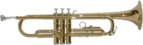 | - aerophone  - chordophone  - ideophone  - membranophone
Musical sounds have… | - simple wave patterns  - waves with no pattern to them
Noises have… | - simple wave patterns  - waves with no pattern to them
  This wave shows a … | - long sound  - short sound  - noise
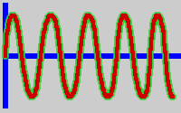  This wave shows a … | - long sound  - short sound  - noise
  This wave shows a … | - long sound  - short sound  - noise

How well did you do?
Save a copy of this on your computer to keep a record of what you have learnt.

